**ASSIGNMENT -1**

**SMART HOME**

|  |  |
| --- | --- |
| Assignment Date | 16 September 2022 |
| Student Name | 1. Dinesh Kumar |
| Student Roll Number | 311019205011 |
| Maximum Mark | 2 Marks |

**PROGRAM**

**/*Smart Home system with Temperature level indication LED,**

**Door opening Servo motor and High Temperature alarm*/**

#include <Servo.h>

Servo s;

void setup()

{

Serial.begin(9600);

pinMode(13,OUTPUT);

pinMode(12,OUTPUT);

pinMode(11,OUTPUT);

pinMode(10,OUTPUT);

s.attach(3);

}

void loop()

{

noTone(13);

digitalWrite(10,0);

digitalWrite(11,0);

digitalWrite(12,0);

digitalWrite(10,1)**;//Green light will be ON to indicate normal temperature**

double a = analogRead (A0);

double t = (((a/1024)*5)-0.5)*100;

Serial.print("Temperature value in Celsius:");

Serial.println(t);

if (t >= 50 & t < 80){

Serial.print("High Temperature ");

digitalWrite(12,1);**//Yellow light will indicate HIGH temperature**

}

if (t>=80){

Serial.println("Critical Temperature ");

digitalWrite(11,0);

digitalWrite(10,0);

digitalWrite(12,1);**//Red light indicates CRITICAL temperature**

tone(13,131);**//At 80 degree celsius the alarm will start**

{

for (int i = 0; i <= 180; i++)

{

s.write(i);**// The Servo motor will also start to open the doors to get out**

delay(10);

}

for (int i = 180; i >= 0; i--)

{

s.write(i);

delay(10);

}

}}

delay(1000);

}

**LIST OF COMPONENT USED**

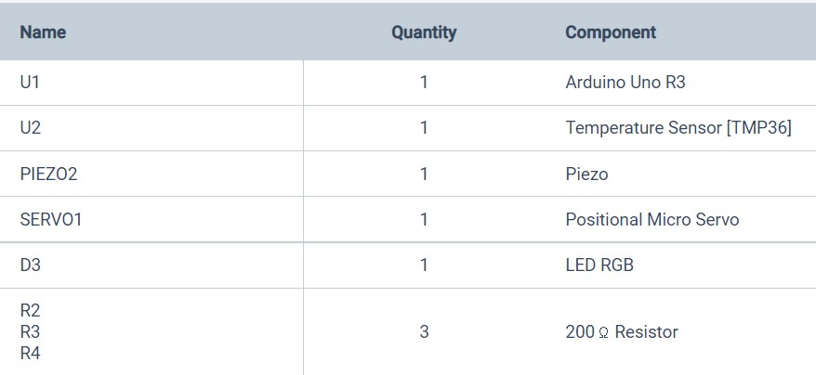

**SCREENSHOT**

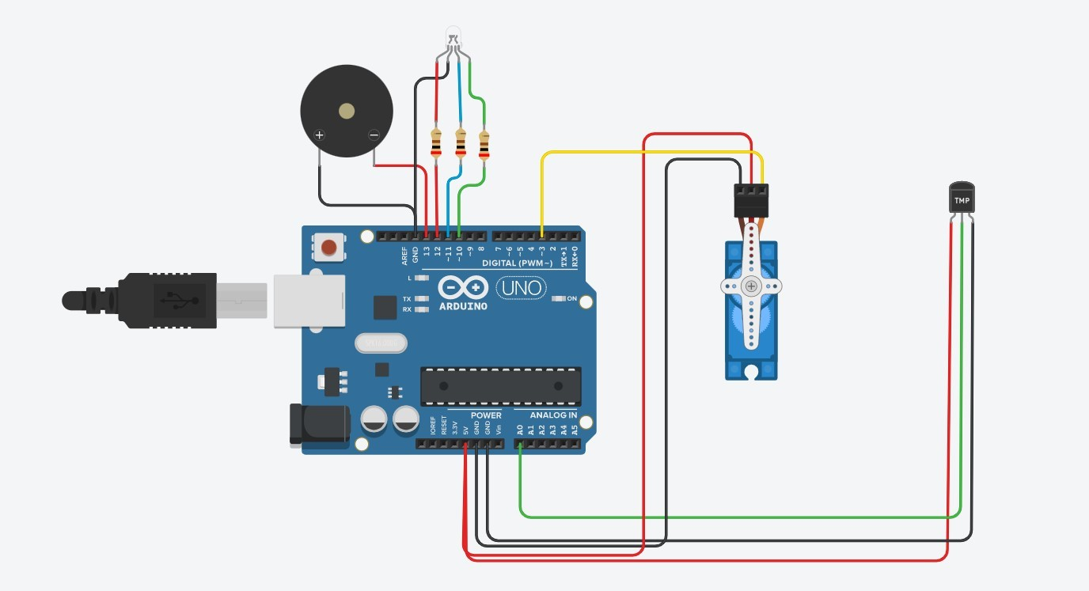

**SCHEMATIC VIEW**

